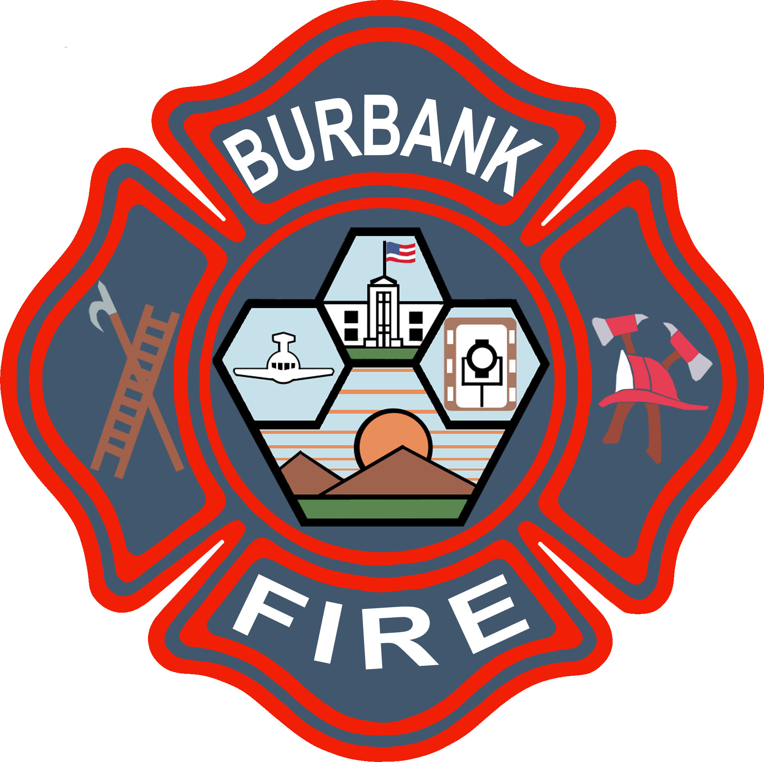
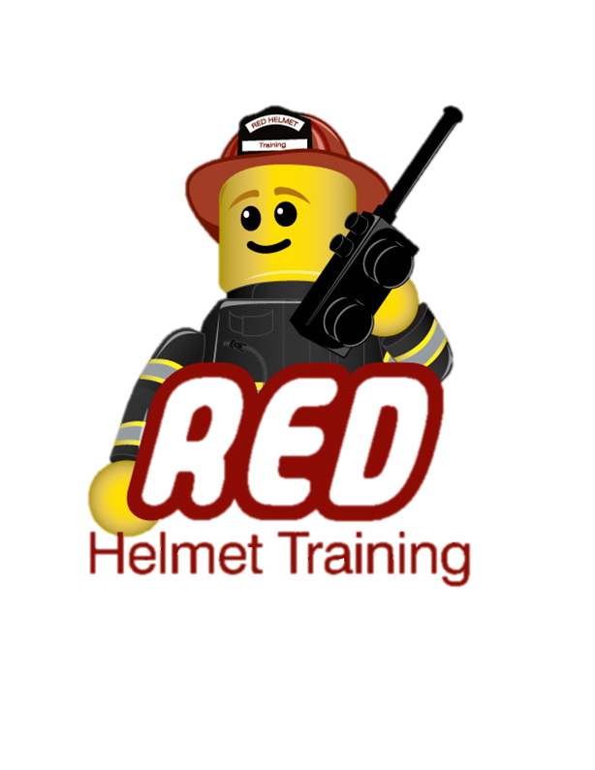
Burbank Fire Department
And
Red Helmet Training LLC

Announce: Training Instructor 1A (2010)
Cognitive Lesson Delivery

Dates: May 6th, 7th, 8th, 13th and 14th, 2013

Times: 8:00 a.m. – 5:00 p.m.

Location: Burbank Fire Training Center
1845 N. Ontario Street, Burbank

Instructor: Captain Dan Casner / Jesse Quinalty

Fees / Materials: $200.00 – Payable to Red Helmet Training
Covers the cost of CSFM student supplement and California State Fire Marshal certificate.

Class Description: Topics include methods and techniques for training in accordance with the latest concepts in career education; selecting, adapting, organizing, and using instructional materials appropriate for teaching cognitive lessons; criteria and methods to evaluate teaching and learning efficiency; and an opportunity to apply major principles of learning through teaching demonstrations.

Prerequisite: None

To register for this course please visit the web site.


www.RedHelmetTraining.com

Red Helmet Training

Playing to Learn, Learning to Play

