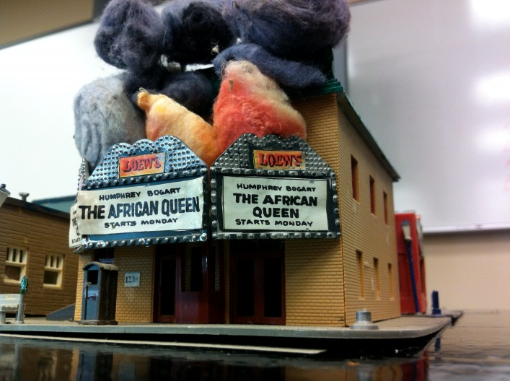
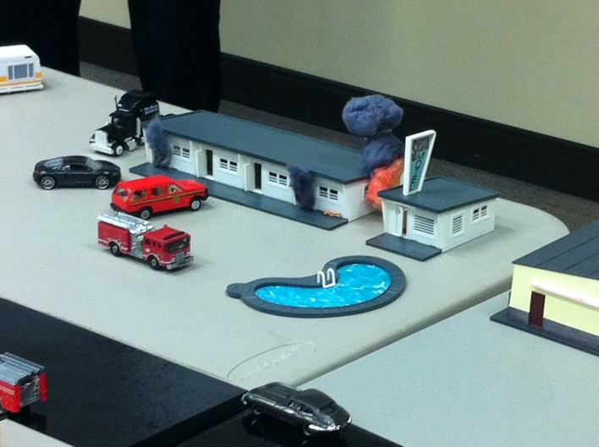
Table Top Command

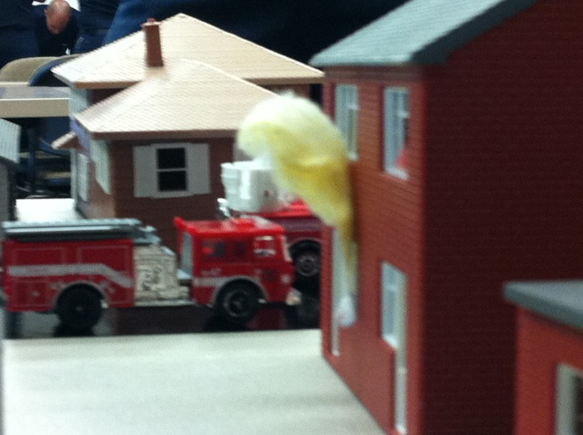
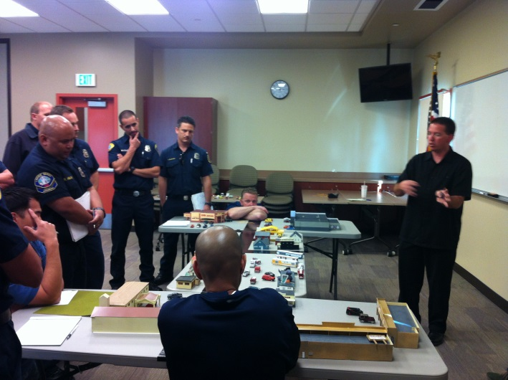

This program uses table top simulation to perfect the participants fireground command skills and assign resources using ACT objectives. The table top simulator is divided into residential, commercial and industrial fires. Day 2 focuses on specialty buildings such as center hallway and big box commercial buildings. It also works toward multiple rescues and incident within an incident.

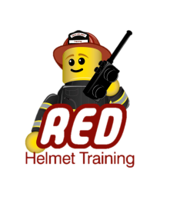
The session objectives are to increase the slide carousels that we use for decision making, have a better understanding of risk vs gain concepts and to prepare students to take command of an incident and assign resources.

For more information, contact Jesse Quinalty at (760) 880-4572
or visit our website at www.RedHelmetTraining.com

