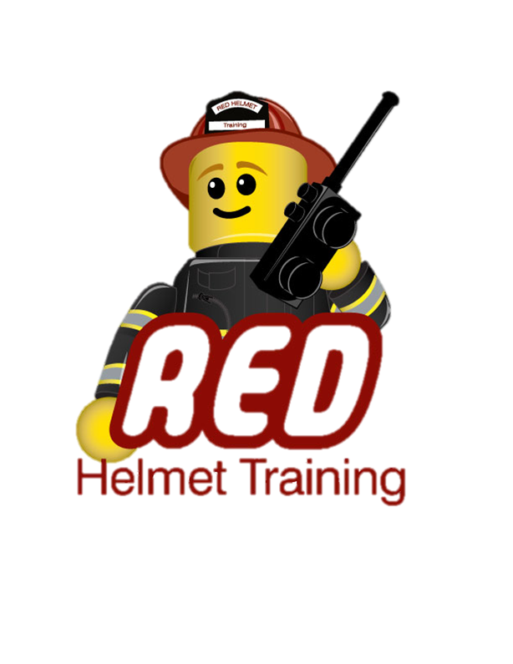
Red Helmet Training
Wildland Division Presents
THE CAMPBELL PREDICTION SYSTEM
FIRE SIGNATURE METHOD COURSE
The Campbell Prediction System (CPS) is a practical way to use on-scene fire behavior observations in order to determine fire behavior strategies and tactics. A combination of scientific research and the knowledge of the successful firefighters' methods and practices are utilized to explain fire behavior. In these situations the observed fire behavior becomes the baseline for fire behavior predictions. A special logic replaces intuition allowing an explanation of how tactics are developed. Developing a strong case for acting on the fire's potential rather than waiting for the fire to make the change would save many of the lives lost because firefighters reacted too late. If people could explain what the potential of the fire is in their situation, few accidents would happen.
The Campbell Prediction System provides the logic and language to do so.
INSTRUCTOR:
Will Spyrison is a CPS instructor and Wildland Consultant, retired Division Chief with the US Forest Service, Los Angeles River Ranger District, Angeles National Forest. He began his firefighting career in 1977 with the Fulton Hotshots in the Sequoia National Forest and served with the Ojai Hotshots from 1979 to 1982 in the Los Padres National Forest. The Ojai Hotshots is where Will met Doug Campbell and learned and began using CPS. In 1995, Will was promoted to Battalion Chief and he served in that position for eight years on the Ojai Ranger District of the Los Padres National Forest. It is at this time that he began to teach the Campbell Prediction System course at the USFS Region 5 training centers. He has since taught CPS in several other Regions for the US Forest Service and to other fire agencies within the United States. Will Spyrison most recently worked as an Expert Fire Witness for a litigation case and is currently developing the InciNotes™ Incident Command System 201 documentation application for Apple™ iPad™.
September 9th, 2014 – Rancho Cucamonga
Please visit Red Helmet Training to register.
This course is being made available for only $50 and is limited in size so register early.
