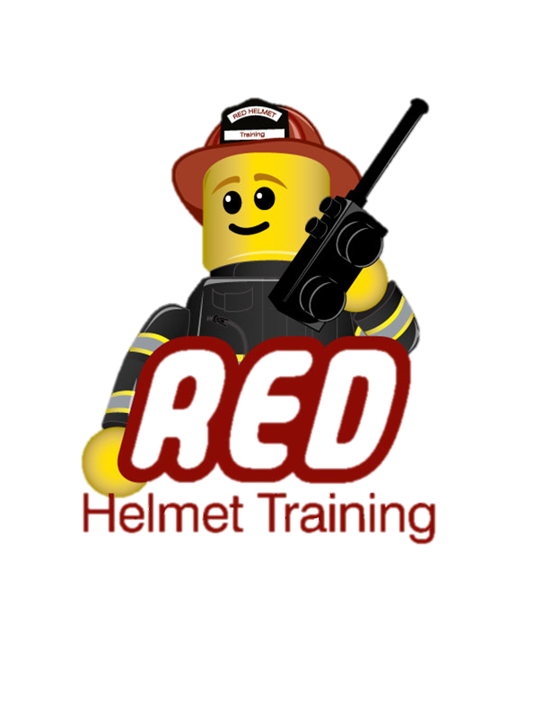
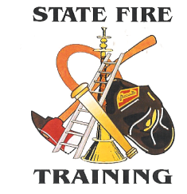 State Fire Training
And
Red Helmet Training

Announce: Fireline Safety Awareness for Hired Vendors

Dates: April 5th, 2014

Times: 8:00 a.m. – 5:00 p.m.

Location: Escondido Fire Department
310 N. Quince, Escondido

Instructor: Captain Jesse Quinalty

Fees / Materials: $70.00 – Payable to Red Helmet Training
Covers the cost of the student manual and California State Fire Marshal certificate.

Class Description: This course provides an awareness of fireline safety to hired vendors who plan to engage in
wildland fire suppression and other incident support activities. Topics include current safety
training, relevant policy and procedures, how to recognize and mitigate risk, and maintain safe
and effective practices while working under agency supervision on an incident. Upon successful completion of training, participants will receive a course completion card valid for one (1) year from date of issue.

To register for this course please visit the web site.
www.RedHelmetTraining.com


Red Helmet Training

Playing to Learn, Learning to Play



Red Helmet Training

Playing to Learn, Learning to Play
www.RedHelmetTraining.com

Course Registration Form

Student Name: Course:

Home Address: City: Zip:

Home Phone: Cell:

E-Mail Address:

Organization: Title:

Please add me to the e-mail list for upcoming classes provided by Red Helmet Training

Reservations are required for all classes unless specified. No phone reservations will be accepted. You must send in a check to reserve your seat, even if your department will pay for you to attend. We will shred your personal check upon receipt of your department check. Please complete this form and submit with your payment made payable to Red Helmet Training.

Checks do not get cashed until the start of class, please date them accordingly. You must call at least one week in advance to cancel or your fee will be retained. You will receive a confirmation e-mail once we have processed your reservation form, along with any course instructions and materials required.

Reservations are on a first come basis unless spots are held by the sponsoring agency / department.

California State Fire Marshal CFSTES and CSTI certificates may take 6 to 8 weeks to process.

If you have any questions, please contact the primary instructor for the course.

Mail all registration forms with payments to:

Red Helmet Training
P.O. Box 1604
Upland, CA 91785

