DEVELOPING DYNAMIC LEADERS:

FROM THE FIREHOUSE TO THE FIREGROUND
A ONE DAY TRAINING SEMINAR WITH:
Mike Alder – Division Chief (Ret)
City of San Bernardino Fire Department
September 10th, 2014 in Rancho Cucamonga
Sign up at www.RedHelmetTraining.com

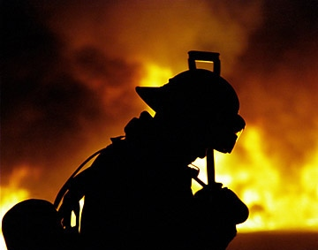
Dynamic Leadership On & Off the Fire Ground!
What does it look like? How is it achieved? How will the fire service culture and the challenges that we face with tomorrow’s fire service play a role in achieving dynamic fire service leadership?
Understanding the culture of your own fire department and the fire service as a whole can be one of the most important steps to becoming an effective and safe Incident Commander. Understanding that every fire situation needs an organized process that identifies the critical fire ground factors, is systematic, is consistent and that the fire ground roles and responsibilities are clearly understood and followed by the entire organization. Finally, it is critical to realize that the fire service is radically changing right before our eyes. 80-million experienced, baby-boomers are exiting the workforce and there is a leadership void that needs to be filled
This training seminar is very interactive and will challenge some of the traditional thoughts about what it takes to make a great fire service leader and company officer

