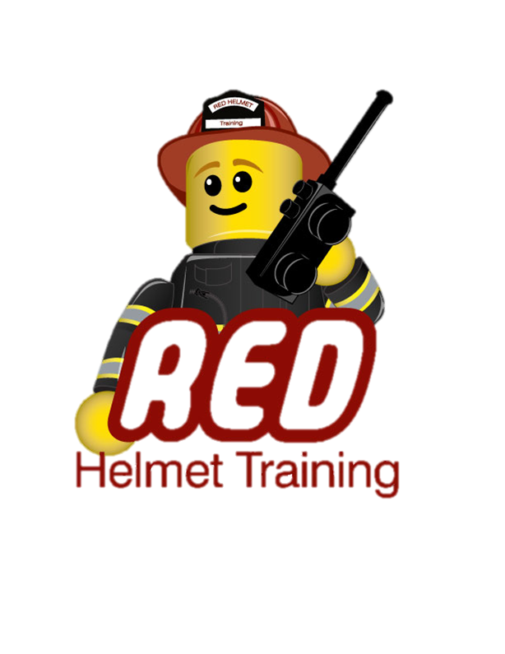
Red Helmet Training
Wildland Division Presents
THE CAMPBELL PREDICTION SYSTEM
FIRE SIGNATURE METHOD COURSE
The Campbell Prediction System (CPS) is a practical way to use on-scene fire behavior observations in order to determine fire behavior strategies and tactics. A combination of scientific research and the knowledge of the successful firefighters' methods and practices are utilized to explain fire behavior. In these situations the observed fire behavior becomes the baseline for fire behavior predictions. A special logic replaces intuition allowing an explanation of how tactics are developed. Developing a strong case for acting on the fire's potential rather than waiting for the fire to make the change would save many of the lives lost because firefighters reacted too late. If people could explain what the potential of the fire is in their situation, few accidents would happen.
The Campbell Prediction System provides the logic and language to do so.
INSTRUCTOR:
Will Spyrison is a CPS instructor and Wildland Consultant, retired Division Chief with the US Forest Service, Los Angeles River Ranger District, Angeles National Forest. He began his firefighting career in 1977 with the Fulton Hotshots in the Sequoia National Forest and served with the Ojai Hotshots from 1979 to 1982 in the Los Padres National Forest. The Ojai Hotshots is where Will met Doug Campbell and learned and began using CPS. In 1995, Will was promoted to Battalion Chief and he served in that position for eight years on the Ojai Ranger District of the Los Padres National Forest. It is at this time that he began to teach the Campbell Prediction System course at the USFS Region 5 training centers. He has since taught CPS in several other Regions for the US Forest Service and to other fire agencies within the United States. Will Spyrison most recently worked as an Expert Fire Witness for a litigation case and is currently developing the InciNotes™ Incident Command System 201 documentation application for Apple™ iPad™.
March 2nd - 4th, 2015 – Rancho Cucamonga
Please visit Red Helmet Training to register.
This course is being made available for only $250 and is limited in size so register early.
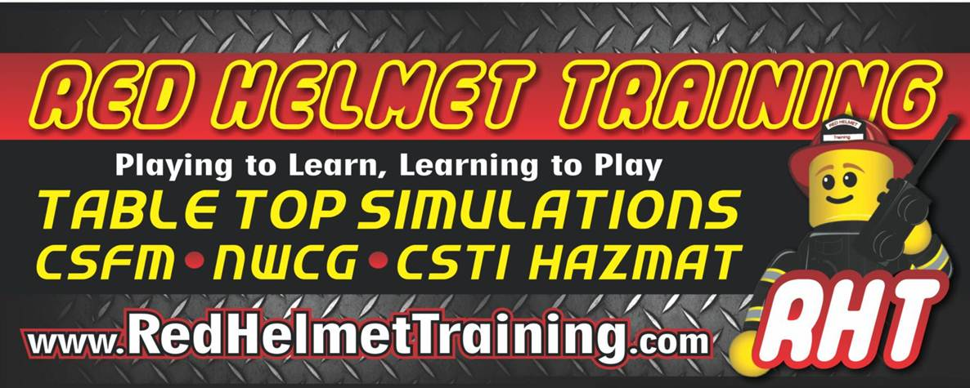

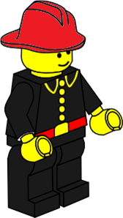
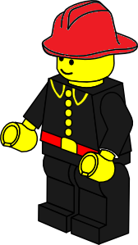
Red Helmet Training

Playing to Learn, Learning to Play
www.RedHelmetTraining.com

Course Registration Form
Student Name: Course:
Course Dates: Course Location:
Home Address: City: Zip:
Home Phone: Cell:
E-Mail Address:
Organization: Title:
To be added to the e-mail list for upcoming classes please visit the Red Helmet Training website.

Reservations are required for all classes unless specified. No phone reservations will be accepted.
You must send in a check or pay electronically to reserve your seat. If your department is paying for you to attend then we will shred your personal check or refund your electronic payment upon receipt of your department check. Checks are not processed until the last day of class so please plan accordingly. Checks should be dated for the last day of the course.
You must call at least one week in advance to cancel or your fee will be retained. You will receive a confirmation e-mail once we have processed your reservation form, along with any course instructions. Any course prerequisites or materials required will be listed on the class flyer. These items are your responsibility to bring to class the first day. If you do not have them you will be dropped from class.
Reservations are on a first come basis unless spots are held by the sponsoring agency / department.
California State Fire Marshal CFSTES and CSTI certificates may take 6 to 8 weeks to process.
If you have any questions, please contact the primary instructor for the course.

Please complete this form and submit with your payment made payable to Red Helmet Training.
Mail all registration forms with payments to:

Red Helmet Training
10601 Church Street #107
Rancho Cucamonga, CA 91730

