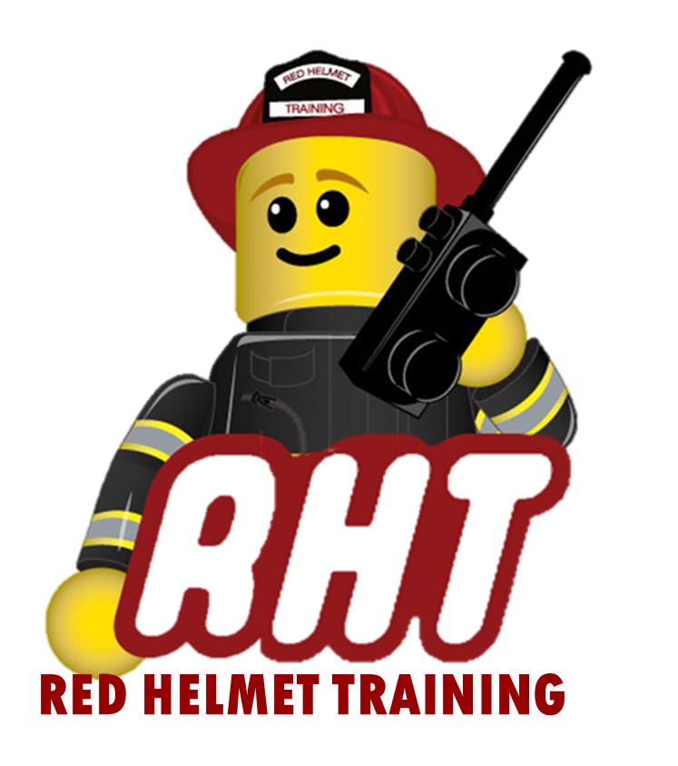
Red Helmet Training
Wildland Fire Courses

Announce: S-200 Initial Attack Incident Commander

Dates: December 16 and 17, 2025

Times: 8:00 a.m. – 5:00 p.m.

Location: Red Helmet Training SoCal
8560 Vineyard Avenue #306
Rancho Cucamonga, CA 91730

Instructor: Jesse Quinalty

Fees / Materials: $300.00 – Payable to Red Helmet Training

Class Description: This course is designed to meet the training needs of the incident commander type 4 (ICT4). It is presented in a discussion / exercise format. The six instructional units include Foundation Skills; Intelligence Gathering and Documentation; Size Up the Incident; Develop a Plan of Action; Post-fire Activities; Evaluating Incident Objectives and Manage the Incident. Evaluation of the student is by unit tests and performance- based evaluations.

Prerequisites: Qualified as a Single Resource Boss

Pre-Course Work https://onlinetraining.nwcg.gov/node/192

Minimum Student Count is 15 Students

Red Helmet Training

Playing to Learn, Learning to Play


Red Helmet Training

Playing to Learn, Learning to Play
www.RedHelmetTraining.com

Course Registration Form

Student Name: SFT ID#:

Course / Location: Dates:

Home Address: City: Zip:

Home Phone: Cell:

E-Mail Address:

Organization: Title:

To be added to the e-mail list for upcoming classes please visit the Red Helmet Training website.

Reservations are required for all classes unless specified. No phone reservations will be accepted.
You must send in a check or pay with PayPal to reserve your seat. If your department is paying for you to attend then we will shred your personal check or deny your PayPal payment upon receipt of your department check. PayPal payments and Checks are not processed until the last day of class so please plan accordingly. Checks should be dated for the last day of the course. Dress code for the facility is business casual or department uniform. No shorts or flip flops will be allowed.

You must call at least one week in advance to cancel or your fee will be retained. You will receive a confirmation e-mail once we have processed your reservation form, along with any course instructions. Any course prerequisites or materials required will be listed on the class flyer. These items are your responsibility to bring to class the first day. If you do not have them you will be dropped from class.

Reservations are on a first come basis unless spots are held by the sponsoring agency / department.

California State Fire Marshal CFSTES and CSTI certificates may take 6 to 8 weeks to process.

If you have any questions, please contact the primary instructor for the course.

Please complete this form and submit with your payment made payable to Red Helmet Training.

Mail all registration forms with payments to:

Red Helmet Training
8560 Vineyard Avenue #306
Rancho Cucamonga, CA 91730

