
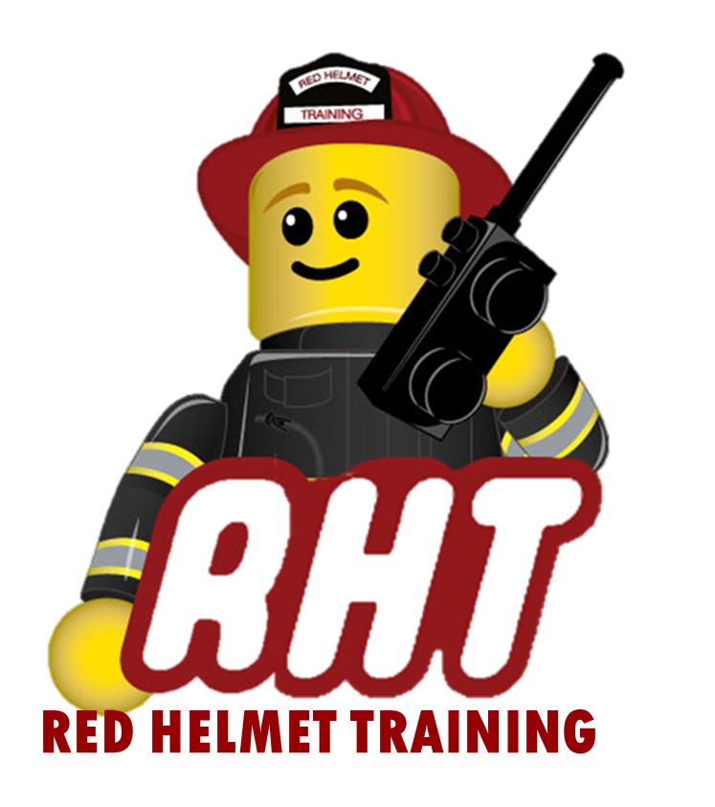
Red Helmet Training
Executive Chief Officer

Announces: Executive Chief Officer 4B
Community and Government Relations

Dates: December 15 and 16, 2025

Location: Cal State San Marcos
184 Santar Place
San Marcos, CA 92069

Instructor: Chief Mike Mingee

Fees / Materials: $300.00 – Payable to Red Helmet Training.

Required Text Chief Officer: Principles and Practice
IAFC, 2nd edition, Jones & Bartlett Learning,
ISBN: 9781284038422

Class Description: This course provides the skills and knowledge needed for the Executive Chief Fire Officer to perform his/her duties safely, effectively, and competently. The overarching theme of this curriculum is assuming a leadership role in community event.

This course requires a large outside the classroom assignment requiring the evaluation of a community event.

Prerequisites: Meet the educational requirements and courses for Chief Fire Officer 3 level



Red Helmet Training

Playing to Learn, Learning to Play

Red Helmet Training

Playing to Learn, Learning to Play
www.RedHelmetTraining.com

Course Registration Form
Student Name: SFT ID#:

Course / Location: Dates:

Home Address: City: Zip:

Home Phone: Cell:

E-Mail Address:

Organization: Title:

To be added to the e-mail list for upcoming classes please visit the Red Helmet Training website.

Reservations are required for all classes unless specified. No phone reservations will be accepted.
You must send in a check or pay with PayPal to reserve your seat. If your department is paying for you to attend then we will shred your personal check or deny your PayPal payment upon receipt of your department check. PayPal payments and Checks are not processed until the last day of class so please plan accordingly. Checks should be dated for the last day of the course. Dress code for the facility is business casual or department uniform. No shorts or flip flops will be allowed.

You must call at least one week in advance to cancel or your fee will be retained. You will receive a confirmation e-mail once we have processed your reservation form, along with any course instructions. Any course prerequisites or materials required will be listed on the class flyer. These items are your responsibility to bring to class the first day. If you do not have them you will be dropped from class.

Reservations are on a first come basis unless spots are held by the sponsoring agency / department.

California State Fire Marshal CFSTES and CSTI certificates may take 6 to 8 weeks to process.

If you have any questions, please contact the primary instructor for the course.

Please complete this form and submit with your payment made payable to Red Helmet Training.

Mail all registration forms with payments to:

Red Helmet Training
8560 Vineyard Avenue #301
Rancho Cucamonga, CA 91730

