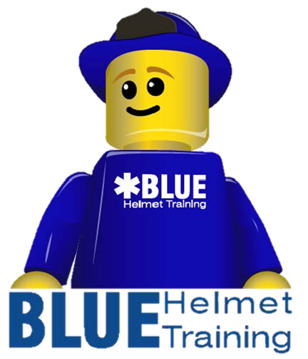
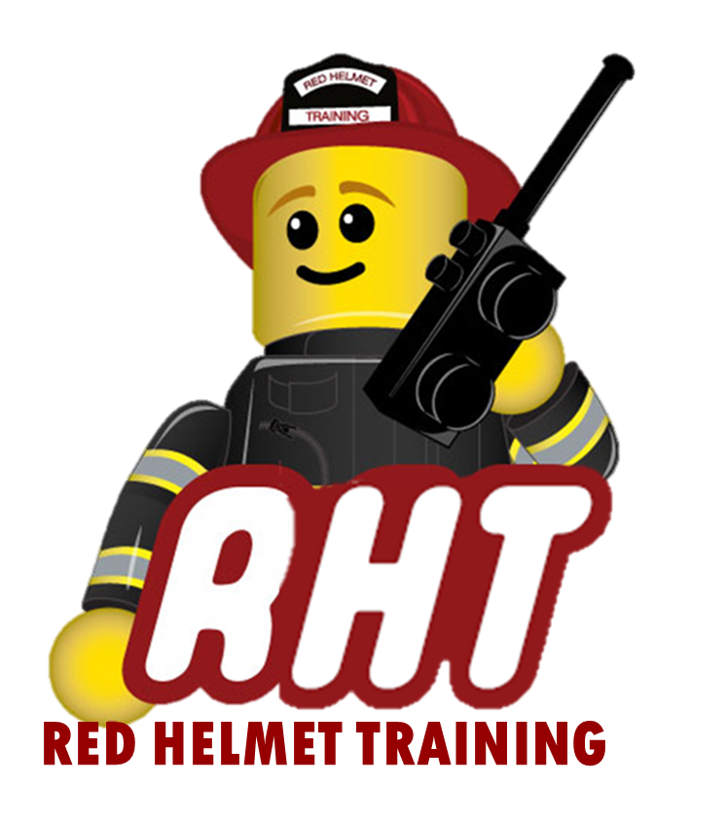
Red Helmet Training
Proudly Presents
S-359 Med Unit Leader

Dates: December 1, 2, and 3, 2025

Times: 8:00 a.m. – 5:00 p.m.

Location: Red Helmet Training – Rancho Cucamonga
8560 Vineyard Avenue #306

Instructor: RHT Staff

Fees / Materials: $360.00 – Payable to Red Helmet Training

Class Description: This course is designed to provide the skills and knowledge needed to perform in the role of Medical Unit Leader. Topics include gathering information, organizing the medical unit, supervising the unit, evaluation, documentation, and demobilization.

Prerequisite: Must be a certified EMT or Paramedic

This course will require a minimum of 10 students.

To register for this course please visit the web site.


www.RedHelmetTraining.com

Red Helmet Training

Playing to Learn, Learning to Play

