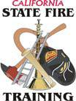
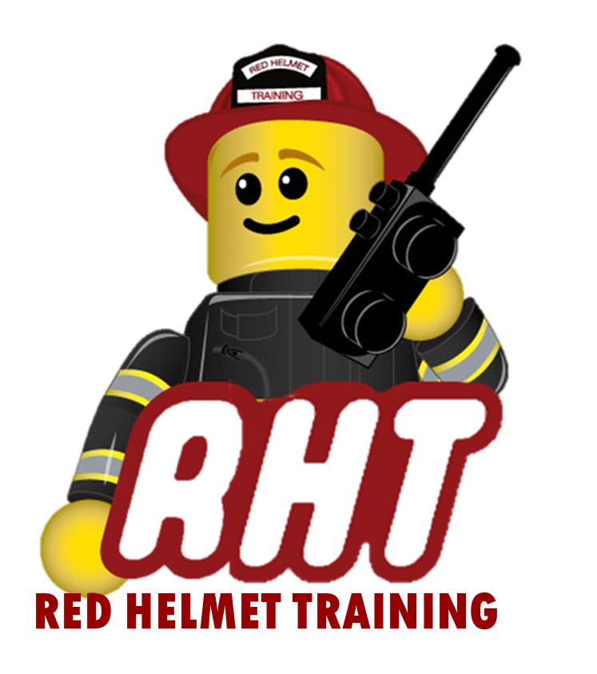
Red Helmet Training Group
Executive Chief Officer Series

Announces: ICS-400 - Advanced ICS

Dates: October 16 and 17, 2025

Location: Red Helmet Training Classroom Facility
8560 Vineyard Avenue #306
Rancho Cucamonga, CA 91730

Instructor: Chief Jeff Ohs

Fees / Materials: $300.00 – Payable to Red Helmet Training.
The State Fire Training Student Supplement
will be provided on the first day of class.

Required Text Firescope ICS 420-1 Field Operations Guide

Class Description: This course directs the student towards an operational understanding of large single-agency and complex multi-agency/multi-jurisdictional incident responses. Topics include fundamentals review for command and general staff, major and/or complex incident/event management, area command, and multi-agency coordination.

Prerequisites ICS-300

This class must have a minimum of 8 students.

To register please visit the website.


www.RedHelmetTraining.com

Red Helmet Training

Playing to Learn, Learning to Play

Red Helmet Training

Playing to Learn, Learning to Play
www.RedHelmetTraining.com

Course Registration Form

Student Name: SFT ID#:

Course / Location: Dates:

Home Address: City: Zip:

Home Phone: Cell:

E-Mail Address:

Organization: Title:

To be added to the e-mail list for upcoming classes please visit the Red Helmet Training website.

Reservations are required for all classes unless specified. No phone reservations will be accepted.
You must send in a check or pay with PayPal to reserve your seat. If your department is paying for you to attend then we will shred your personal check or deny your PayPal payment upon receipt of your department check. PayPal payments and Checks are not processed until the last day of class so please plan accordingly. Checks should be dated for the last day of the course. Dress code for the facility is business casual or department uniform. No shorts or flip flops will be allowed.

You must call at least one week in advance to cancel or your fee will be retained. You will receive a confirmation e-mail once we have processed your reservation form, along with any course instructions. Any course prerequisites or materials required will be listed on the class flyer. These items are your responsibility to bring to class the first day. If you do not have them you will be dropped from class.

Reservations are on a first come basis unless spots are held by the sponsoring agency / department.

California State Fire Marshal CFSTES and CSTI certificates may take 6 to 8 weeks to process.

If you have any questions, please contact the primary instructor for the course.

Please complete this form and submit with your payment made payable to Red Helmet Training.

Mail all registration forms with payments to:

Red Helmet Training
8560 Vineyard Avenue #301
Rancho Cucamonga, CA 91730

