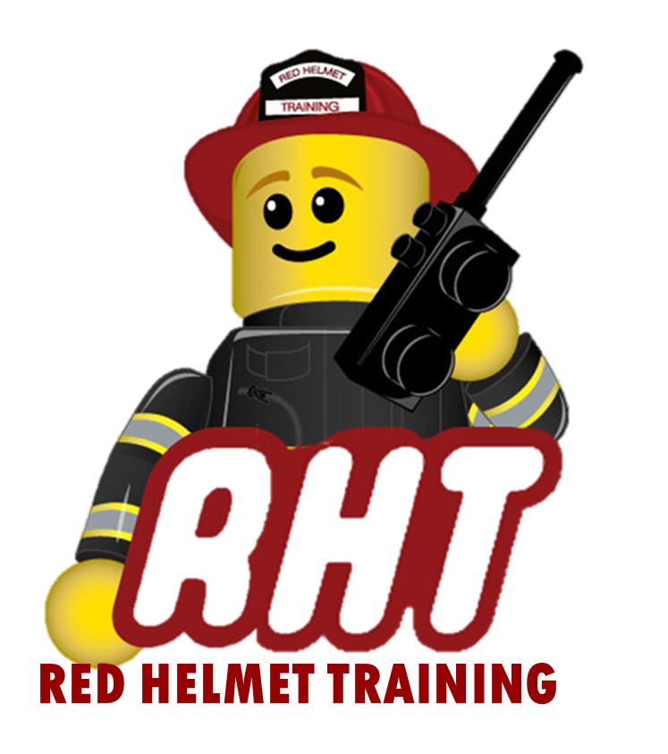
Red Helmet Training
Company Officer Courses

Announce: Instructor 1 – Instructional Methodology

Dates: July 28, 29, 30, 31, and Aug. 1, 2025

Times: 8:00 a.m. – 5:00 p.m.

Location: CalFire Atwater Training Center
4225 Hospital Road
Atwater, CA 95301

Instructor: John Price & Jesse Quinalty

Fees / Materials: $460.00 – Payable to Red Helmet Training

Required Text: IFSTA Fire & Emergency Services Instructor

Class Description: This course provides the skills and knowledge needed for the entry level professional instructor to perform his or her duties safely, effectively, and competently. The curriculum is based on the 2025 edition of NFPA 1041.
At the end of this course, candidates for Instructor I certification will be able to teach and deliver instruction from a prepared lesson plan utilizing instructional aids and evaluation instruments. The Instructor I will also be able to adapt a lesson plan and complete the reporting requirements to the local jurisdiction.

To register for this course please visit the web site.


www.RedHelmetTraining.com

Red Helmet Training

Playing to Learn, Learning to Play

