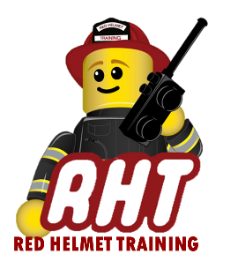
Red Helmet Training

Fire Prevention Courses

Announce: Plans Examiner 1B – Plan Review for
Fire Protection and Life Safety Systems

Dates: June 7, 8, and 9, 2024 (F, S, Su)

Times: 8:00 a.m. – 5:00 p.m.

Location: Red Helmet Training Classrooms
10601 Church Street #107
Rancho Cucamonga CA 91730

Instructor: Brian Pachman

Course Fees: $360.00 – Payable to Red Helmet Training

Materials: Current California Fire and Building Codes
Engineers and Architectural Scale, Calculator
NFPA 13, 14, 17A and 72

Class Description: This course provides the knowledge and skills that prepare a plan examiner to evaluate fire flow compliance and identify requirements and review installation plans for fire protection and life safety systems.

Prerequisite: Plans Examiner 1A

To register for this course please visit the web site.

www.RedHelmetTraining.com

Red Helmet Training

Playing to Learn, Learning to Play
Red Helmet Training

Playing to Learn, Learning to Play
www.RedHelmetTraining.com

Course Registration Form

Student Name: Course:

Location: Dates:

Home Address: City: Zip:

Home Phone: Cell:

E-Mail Address:

Organization: Title:

To be added to the e-mail list for upcoming classes please visit the Red Helmet Training website.

Reservations are required for all classes unless specified. No phone reservations will be accepted.
You must send in a check or pay electronically to reserve your seat. If your department is paying for you to attend then we will shred your personal check or refund your electronic payment upon receipt of your department check. Checks are not processed until the last day of class so please plan accordingly. Checks should be dated for the last day of the course. Dress code for the facility is business casual or department uniform. No shorts or flip flops are allowed.

You must call at least one week in advance to cancel or your fee will be retained. You will receive a confirmation e-mail once we have processed your reservation form, along with any course instructions. Any course prerequisites or materials required will be listed on the class flyer. These items are your responsibility to bring to class the first day. If you do not have them you will be dropped from class.

Reservations are on a first come basis unless spots are held by the sponsoring agency / department.
California State Fire Marshal CFSTES and CSTI certificates may take 6 to 8 weeks to process.

If you have any questions, please contact the primary instructor for the course.

Please complete this form and submit with your payment made payable to Red Helmet Training.

Mail all registration forms with payments to:

Red Helmet Training
10601 Church Street #107
Rancho Cucamonga, CA 91730

