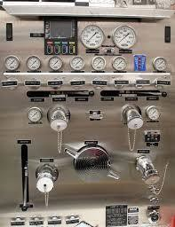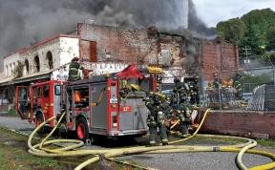
When:

May 2024
8th, 9th, & 10th Where:
Virtual Meetings

Time: 9:00 to 3:00
Cost : $300
REGISTER:
FirefighterCOACH.com

(909)466-4671
www.redhelmettraining.com

DRIVEN TO BE AN ENGINEER
Course Overview
This course is designed for any fire service personnel who are looking to take that next step in the promotional process to becoming a Fire Engineer.
The course will cover daily pre-trip inspections, driving responsibilities, legalities, hydraulics, pumping scenarios, unit positioning, engine and pump troubleshooting, mock interview, written practice test and much more.
We will assist you with understanding what it takes to make that move from the back seat to the front seat and giving you the tools to be successful.

“Trust your hopes, not your fears,

take that next step.”

