
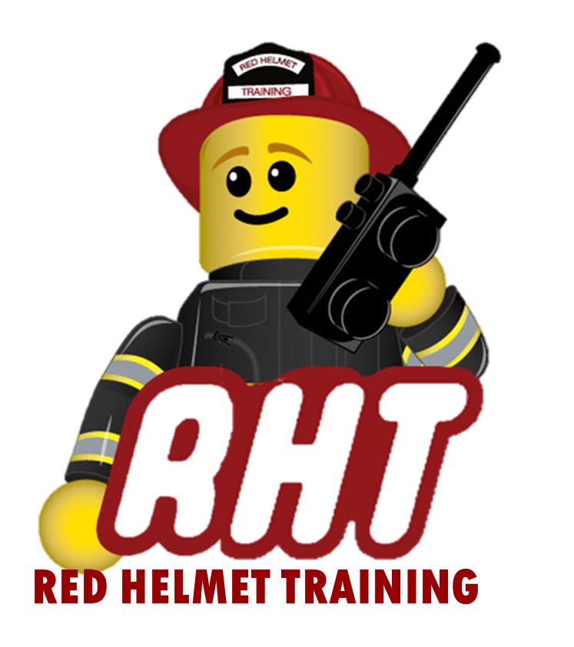
Red Helmet Training
Chief Fire Officer Series

Announces: Chief Fire Officer 3A
Human Resource Management

Dates: June 5, 6, and 7, 2023

Location: Red Helmet Training Classrooms
10601 Church Street #107
Rancho Cucamonga, CA 91730

Instructor: Chief Kevin Diamond

Fees / Materials: $360.00 – Payable to Red Helmet Training.

Required Text Chief Officer: Principles and Practice
IAFC, 2nd or 3rd edition, Jones & Bartlett
ISBN: 9781284172478

Class Description: This course provides students with a basic knowledge of the human resources requirements related to the roles and responsibilities of a Chief Fire Officer including developing plans for providing employee accommodation, developing hiring procedures, establishing personnel assignments, describing methods of facilitating and encouraging professional development, developing an ongoing education training program, developing promotion procedures, developing proposals for improving employee benefits, and developing a measurable accident and injury prevention program.



Red Helmet Training

Playing to Learn, Learning to Play
Red Helmet Training

Playing to Learn, Learning to Play
www.RedHelmetTraining.com

Course Registration Form
Student Name: Course:

Course Dates: Course Location:
Home Address: City: Zip:

Home Phone: Cell:

E-Mail Address:

Organization: Title:

To be added to the e-mail list for upcoming classes please visit the Red Helmet Training website.

Reservations are required for all classes unless specified. No phone reservations will be accepted.
You must send in a check or pay with PayPal to reserve your seat. If your department is paying for you to attend then we will shred your personal check or deny your PayPal payment upon receipt of your department check. PayPal payments and Checks are not processed until the last day of class so please plan accordingly. Checks should be dated for the last day of the course. Dress code for the facility is business casual or department uniform. No shorts or flip flops will be allowed.

You must call at least one week in advance to cancel or your fee will be retained. You will receive a confirmation e-mail once we have processed your reservation form, along with any course instructions. Any course prerequisites or materials required will be listed on the class flyer. These items are your responsibility to bring to class the first day. If you do not have them you will be dropped from class.

Reservations are on a first come basis unless spots are held by the sponsoring agency / department.

California State Fire Marshal CFSTES and CSTI certificates may take 6 to 8 weeks to process.

If you have any questions, please contact the primary instructor for the course.

Please complete this form and submit with your payment made payable to Red Helmet Training.

Mail all registration forms with payments to:

Red Helmet Training
10601 Church Street #107
Rancho Cucamonga, CA 91730

