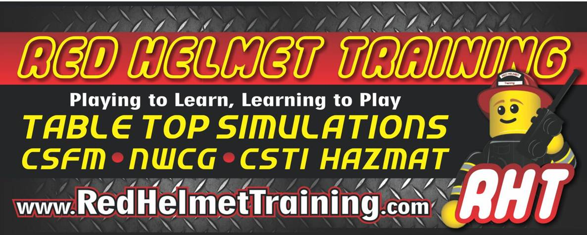

Learning From Leaders II – 2021 edition
February 11 with Kevin Ward and Paul Sullivan

Care You Ready for the Collar Brass?

No position in the fire service is more crucial than the company officer. As the supervisor of the frontline direct service delivery team, no one is in a better position to affect the crew and the public in a positive way.
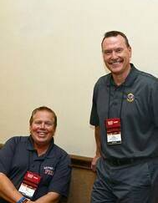
This course will help existing and future company officers make a successful transition to the company officer leadership role, both around the station and at the emergency scene.
This fast-paced class covers many practical applications to include:
- Increasing your leadership skills & abilities
- Interpersonal relationships and understanding personality types
- Working effectively as a team
- Mentoring future leaders
- Customer Service skills & firefighter empowerment
- Situational Awareness & Risk Management
- Developing effective fireground leadership and communications

Dealing with the Tough Stuff
A Discipline Primer for Leaders

This Dealing with disciplinary problems is one of the toughest issues a company officer will face. We are programmed to be get along and function like family – so knowing how to correct bad behavior does not always come naturally. In this class we will discuss the meaning of discipline and how culture impacts our ability to discipline. We will discuss the difference between Property and Non-Property Right Discipline, as well as laws and
rules affecting how we impart discipline; to include an employee’s constitutional right to due process. We will provide real-world examples and explain best practices when it comes to writing-up an employee and follow this with situational exercises.

This course will be hosted at Red Helmet Training
LOCATION: 10601 Church Street #107, Rancho Cucamonga CA 91730
DATES: February 11, 2021 (08:30 – 12 and 1 – 4:30)
REGISTER on our website: www.RedHelmetTraining.com
$50 for one session or $80 for both

