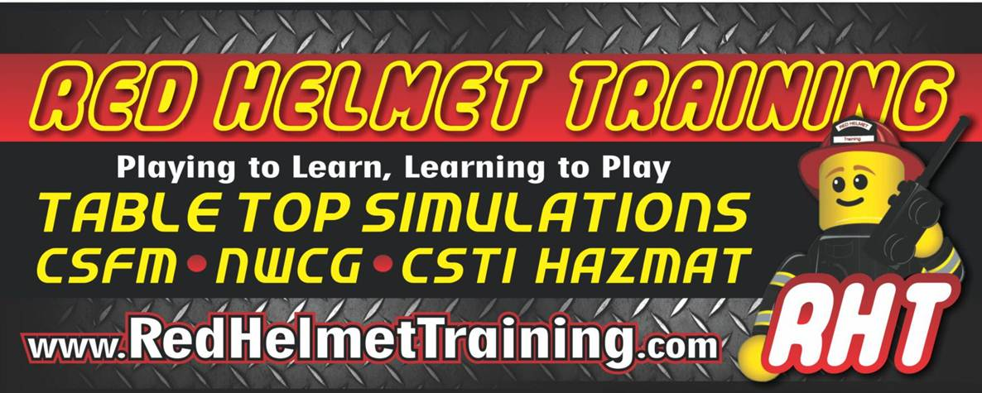

Table Top Command
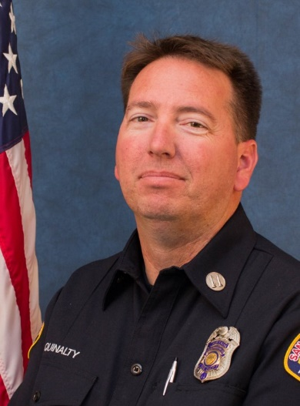
November 20th with Captain Jesse Quinalty (Red Helmet Training)
This program uses a miniature table top city to perfect the participants fireground
command skills and assign resources using ACT objectives. The table top simulator
is divided into residential, commercial and industrial fires. It also focuses on specialty
buildings such as center hallway and big box commercial buildings. It also works
toward multiple alarms and incident within an incident.

The session objectives are to increase the slide carousels that we use for decision
making, have a better understanding of risk vs gain concepts and to prepare
students to take command of an incident and assign resources.

The program then looks at how to develop tasks and tactics for this strategy
Instructor Bio
using the division of labor. This course reviews command elements with a focus
on new fire behavior, risk assessment and control of resources.

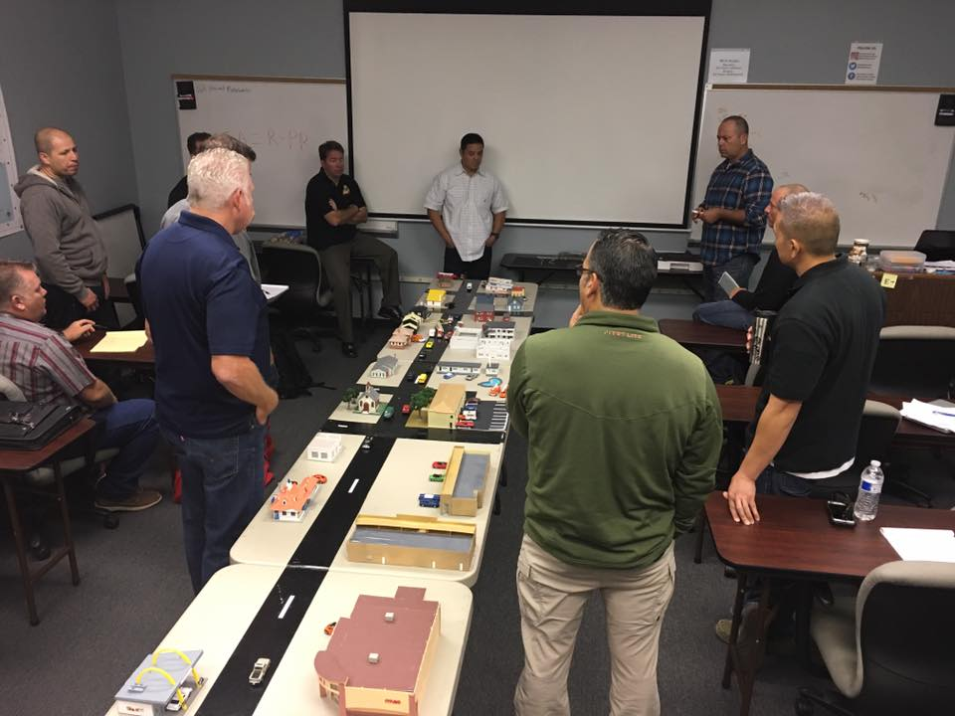
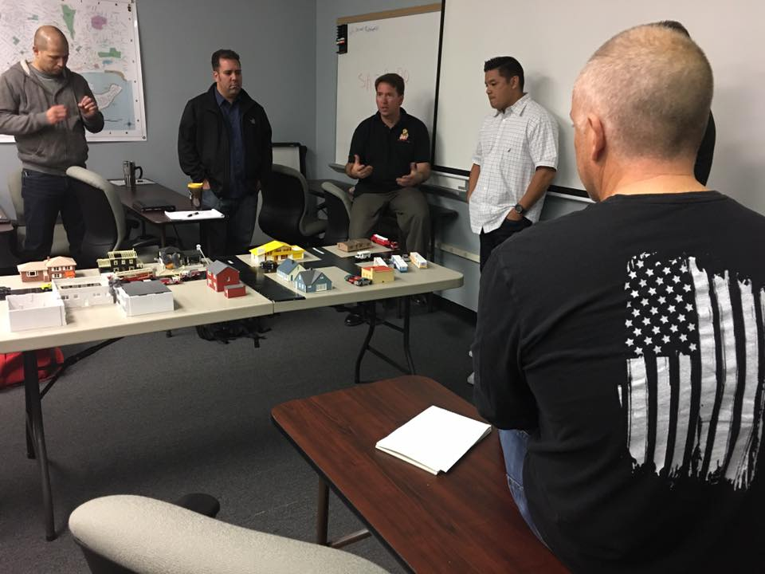

This course will be hosted at Red Helmet Training
LOCATION: 10601 Church Street #107, Rancho Cucamonga
DATES: November 20, 2020 TIMES: 0800 – 1700 hours
REGISTER at: www.RedHelmetTraining.com
Course Cost is $75 – Space is limited

