SLAB SAVERS
Strategy and Tactics Workshop

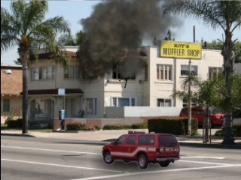

This program first looks at the SLAB (Safety Profile, Life Profile, Air Track and Building) and utilizes the information to come up with the Strategy. More importantly whether the fire is offensive or defensive based on this situational awareness and 360 walk around. It is aligned with the IAFC Rules of Engagement and the Everyone Goes Home Program to work through a risk vs. gain process.

The program then looks at how to develop tasks and tactics for this strategy using the division of labor at the tactics and task level.

The tactics are assigned based on SAVERS.
• Search / Rescue
• Attack
• Ventilation
• Extension / Exposures
• Rapid Intervention Crew (RIC)
• Salvage

This interactive course utilizes digital simulation and dash cam videos to enhance the rapid decision making process. This course reviews basic command elements during structure fires with a focus on new fire behavior and reading smoke, risk assessment and control of resources. It focuses on condition reports using the BELOWME method. This course has over 100 digital simulations available for use.
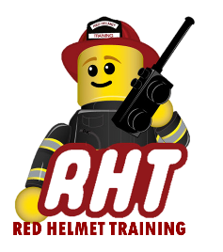
September 29th, 2020
Registration is $75 for the workshop
To be hosted at Red Helmet Training
10601 Church Street #107, Rancho Cucamonga
To register our website at www.RedHelmetTraining.com

