Up Size
Your Size Up
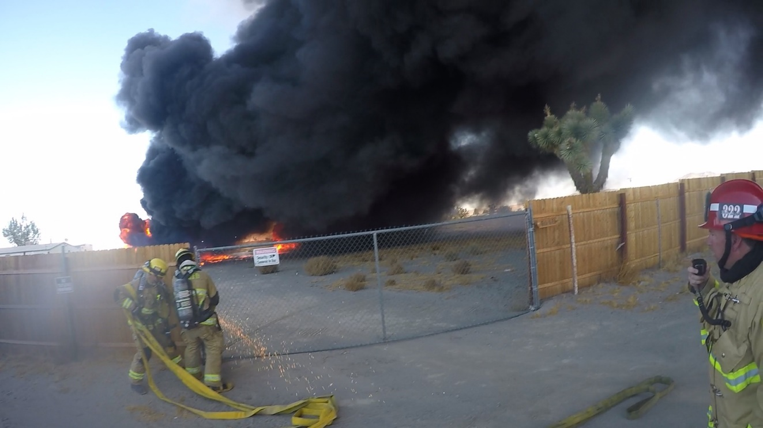

This program will discuss how to conduct a size up using the BELOW ME method but more importantly how to use it to lay the foundation for the strategy and tactics. We will break down components of the size up including how to read buildings and smoke, conduct life profiles, verify and mitigate hazards, determine fire attack methods, choose a mode of operation and evaluate resources needs.

This program will utilize digital simulation as well as fireground video to practice the process of conducting a size up and then translating it into a report that “paints the picture”. This course reviews basic command elements during structure fires with a focus on new fire behavior and reading smoke, risk assessment and control of resources.

Seating will be limited to 8 students to maintain social distancing so register early.
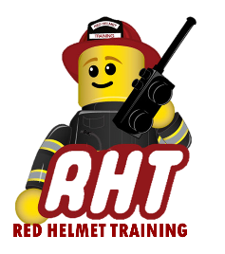
August 31st, 2020
Registration is $75 for the workshop
To be hosted at Red Helmet Training
10601 Church Street #107, Rancho Cucamonga
To register our website at www.RedHelmetTraining.com

