California State Fire Marshal Driver Operator 1A
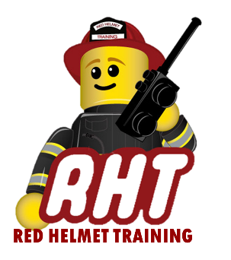
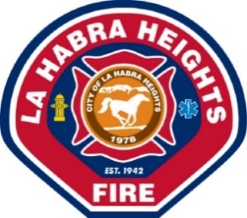
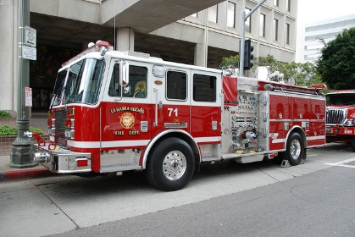
PRESENTED BY
La Habra Heights Fire Department
DATES: March 13, 14, 20 and 21, 2020 (Attendance required for all 4 days)
TIMES: 0800-1800 HOURS EACH DAY
LOCATION: La Habra Heights Fire Department
1245 N Hacienda Rd
La Habra Heights, CA 90631
COST: $400 for Non-LHH employees

Instructor: Arnold Klement - Red Helmet Training
Certification: CFSTES Fire Apparatus Driver/Operator I

Today’s Fire Service demands individuals to obtain a variety of skill sets. This course will add to that skill set by providing the student with information on driver’s responsibilities, recognized standards, and related laws for fire apparatus. Topics include basic inspection, documentation, maintenance, and troubleshooting fire apparatus, and techniques for driving and positioning apparatus. The completion of this course will strengthen your driver/operator skills and at the same time make you a more valuable employee for your firefighting agency. Sign up today. www.RedHelmetTraining.com

