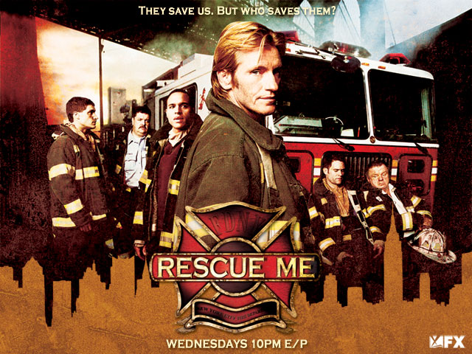

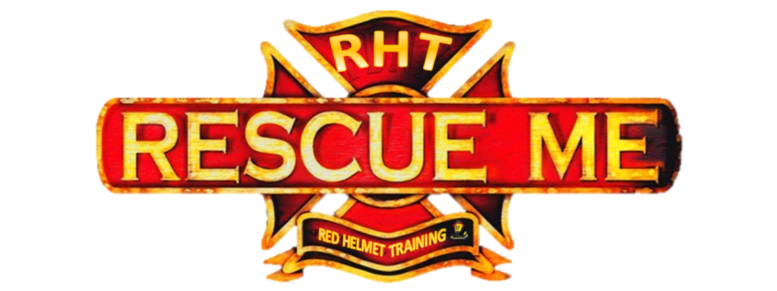

Rescue Me – Strategies and Tactics for Employee Fires
This program utilizes basic firefighting and incident command terminology to extinguish and prevent the employee fires as a Company Officer or first level Chief Officer. The fire service spends an enormous amount of time teaching us how to respond to fires but we usually fight more fires in the fire station then we do out in the streets.

The program will first use the same size up process taught in our Strategies and Tactics courses to determine the strategy; BELOW ME.

- Building Profile
- Extent of Fire
- Location of Fire
- Occupancy
- Water Supply
- Mode of Operation
- Extra Resources

The workshop then utilizes tactics to solve the problem with RECEO VS.

The course will look closely at Preventing Employee Fires, Installing Detection and Suppression Systems, Arson Fires, Conducting a Risk Assessment, Assuming or Passing Command, Command and Control of Employee Fires and After Action Reviews.

The class is also filled with case studies, employee fire training videos and fire simulations.
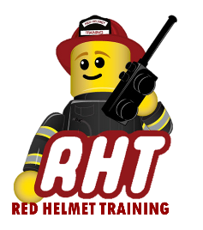
January 23rd, 2020
Registration is $75 for the full day workshop
10601 Church Street #107, Rancho Cucamonga
To register our website at www.RedHelmetTraining.com

