California State Fire Marshal Driver Operator 1B
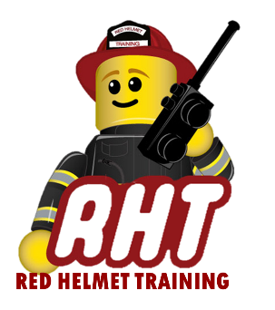
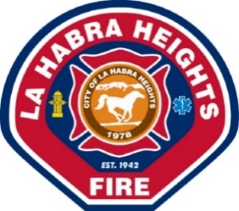
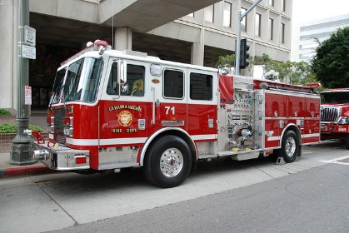
PRESENTED BY
La Habra Heights Fire Department
DATES: September 13, 14, 20 and 21, 2019 (Attendance required for all 4 days)
TIMES: 0800-1800 HOURS EACH DAY
LOCATION: La Habra Heights Fire Department
1245 N Hacienda Rd
La Habra Heights, CA 90631
COST: $450 for Non-LHH employees

Instructor: Arnold Klement - Red Helmet Training
Certification: CFSTES Fire Apparatus Driver/Operator I

Today’s Fire Service demands individuals to obtain a variety of skill sets. This course provides information on pumping apparatus preventive maintenance and operations. Topics include routine tests, inspections, and servicing functions; producing hand, master, and foam fire streams, relay pump operations; and supplying water to fire sprinkler and standpipe systems. The completion of this course will strengthen your driver/operator skills and at the same time make you a more valuable employee for your firefighting agency. Sign up today. www.RedHelmetTraining.com

