
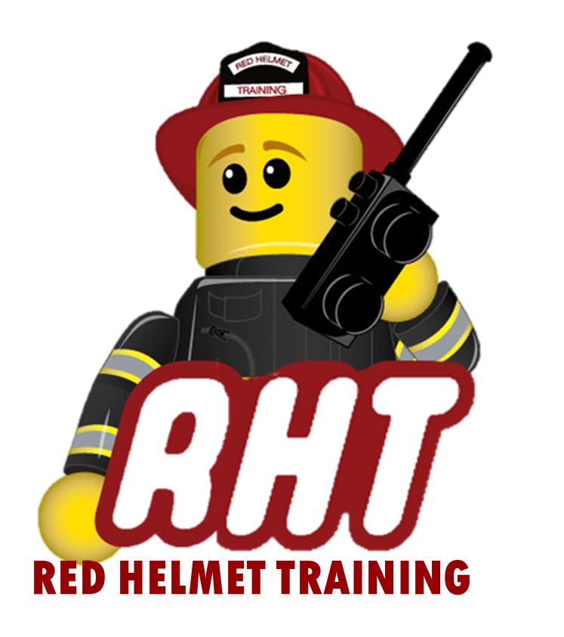
Red Helmet Training Group
Wildland Training Division

Announces: S-230 Crew Boss (Blended Course)

Dates: May 18th, 2018
On-line portion must be completed prior

Times: 8:00 a.m. – 5:00 p.m.

Location: La Habra Heights Fire Department
1245 Hacienda Road, La Habra Heights

Instructor: Captain Jesse Quinalty

Fees / Materials: $75.00 – Payable to Red Helmet Training
This course gives local certification from the La Habra Heights Fire Department. If your department requires a CSFM then you must attend the full course at Red Helmet Training.

Class Description: Training for the single resource boss position from initial dispatch through demobilization to the home unit. Topics include operational leadership, preparation and mobilization, assignment preparation, risk management, entrapment avoidance, safety and tactics, offline duties, demobilization, and post incident responsibilities.

Prerequisites: S-130, S-190, S-290 (On-line is Acceptable)

To register for this course please visit the web site.
www.RedHelmetTraining.com



Red Helmet Training

Playing to Learn, Learning to Play

Red Helmet Training

Playing to Learn, Learning to Play
www.RedHelmetTraining.com

Course Registration Form

Student Name: Course:

Course Dates: Course Location:

Home Address: City: Zip:

Home Phone: Cell:

E-Mail Address:

Organization: Title:

To be added to the e-mail list for upcoming classes please visit the Red Helmet Training website.

Reservations are required for all classes unless specified. No phone reservations will be accepted.
You must send in a check or pay with PayPal to reserve your seat. If your department is paying for you to attend then we will shred your personal check or deny your PayPal payment upon receipt of your department check. PayPal payments and Checks are not processed until the last day of class so please plan accordingly. Checks should be dated for the last day of the course.

You must call at least one week in advance to cancel or your fee will be retained. You will receive a confirmation e-mail once we have processed your reservation form, along with any course instructions. Any course prerequisites or materials required will be listed on the class flyer. These items are your responsibility to bring to class the first day. If you do not have them you will be dropped from class.

Reservations are on a first come basis unless spots are held by the sponsoring agency / department.

California State Fire Marshal CFSTES and CSTI certificates may take 6 to 8 weeks to process.

If you have any questions, please contact the primary instructor for the course.

Please complete this form and submit with your payment made payable to Red Helmet Training.

Mail all registration forms with payments to:

Red Helmet Training
10601 Church Street #107
Rancho Cucamonga, CA 91730

